Contents

EC2 1

**Create EC2 Instance** 1

**Create our own AMI** 1

**Bootstrap script** 2

**Elastic Load Balancer** 2

**Auto Scaling Lab** 2

**EFS LAB** 5

# EC2

## **Create EC2 Instance**

1. Create EC2 Instance with Redhat EL 8 AMI and go over all the options while creation
   1. Connect to EC2 from Git Bash
      1. Make sure Port No 22 is added to Inbound Rules in Security Group
   2. Within EC2 go over
      1. Description
      2. Status Checks
      3. Monitoring
      4. Tags
   3. Updates on EC2
      1. sudo su
      2. yum update -y
      3. yum install httpd -y
      4. yum install nano -y
      5. cd /var/www/html
      6. nano index.html

<hello><h1>Hello to EC2 Srvice</h1></html>

* + 1. service httpd start
    2. Go to Browser type publicIP/index.html
       1. Make sure Port No 80 is added to Inbound Rules in Security Group
  1. Terminate the EC2 Instance

## **Create our own AMI**

* From EC2 Dashboard 🡪 Volumes (at Left Menu)
* Select the Volume from which you want to create the AMI
* Volume 🡪 Actions 🡪 Create Snapshot
* Go to Snapshots and Select the one we created
* Snapshot 🡪 Actions
  + Create Image
* Create EC2 Instance from our own AMI by selecting AMI from MyAMI

## **Bootstrap script**

#!/bin/bash

yum update -y

yum install httpd -y

service httpd start

## **Elastic Load Balancer**

* Create 2 EC2 instances with Amazon Redhat AMI
* Login to EC2 instance with SSH
* sudo su
* sudo yum install httpd -y
* service httpd start
* service httpd status
* chkconfig httpd on – To make sure httpd is on whenever you reboot your system
* cd /var/www/html
* nano index.html (For First EC2 Instance)
  + <html><h1>Welcome to AWS Instance-01</h1></html>
* nano index.html (For Second EC2 Instance)
  + <html><h1>Welcome to AWS Instance-02</h1></html>
* AWS Console 🡪 Load Balancers
* **Click on create Application Load Balancer**
  + Load Balancer Name –
  + Internet Facing
* Step 2: Select Security Group
* Step 4 – Configure Health Check
  + Ping path /index.html
  + Advance Details
    - Response time out 2 secs
    - Interval 5 sec
    - Unhealthy threshold (Consecutive Health checks)
    - Healthy threshold
* Step 5 - Add EC2 instances
* Step 6 – Add Tags
* Monitor the health check and Instances Tab under ELB
* Copy DNS Name and open in Browser
  + You don’t get Public IP for LB you will get DNS
* The Request goes to Instance-01 and Instance-02 when you keep refreshing your Browser

## **Auto Scaling Lab**

1. Login to AWS Console
2. Go to EC2 Dashboard
3. Go To Launch Configurations under Auto Scaling at left menu
4. Create Launch Configuration
   1. Provide Launch Configuration Name
   2. Select AMI (Redhat Enterprise Linux 8)
   3. Instance Type – t2.micro
   4. Security Group – Select an existing security group
   5. Select key pair
   6. Select the checkbox for I acknowledge
   7. Click on Create Launch Configuration button
5. Once Launch Configuration is created
6. Select Launch Configuration 🡪 Actions 🡪 Create Auto Scaling Group
   1. Provide the Name and click on Next button at bottom right of the page
   2. Select All subnets from below page

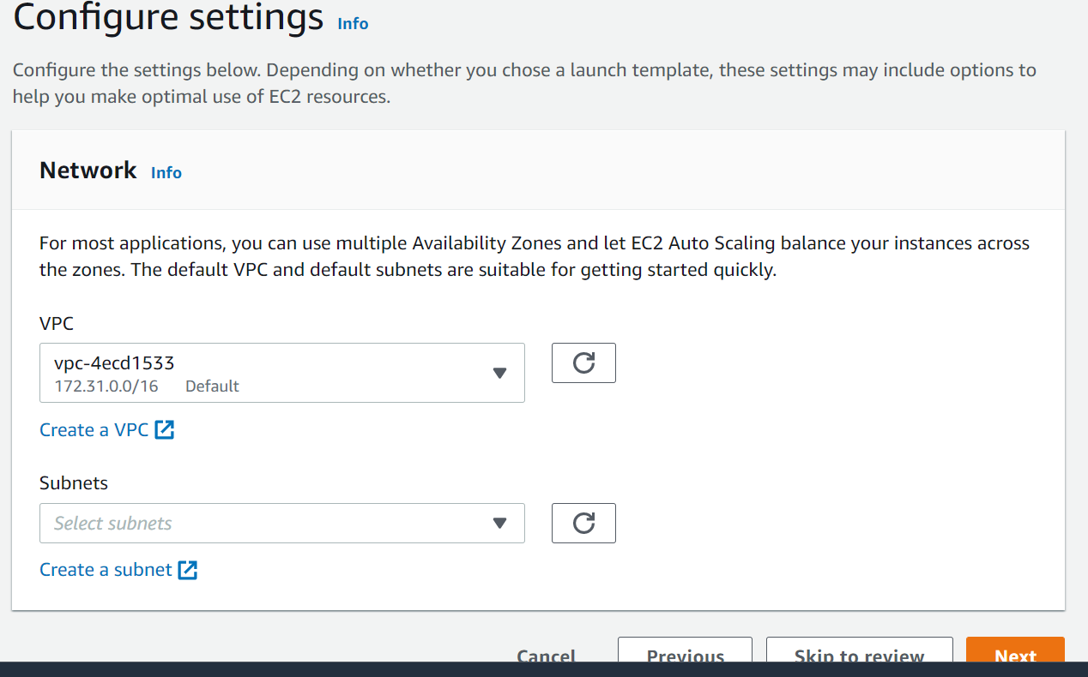

* 1. Click on Next
  2. Enter 180 for Health Check Grace Period in below page

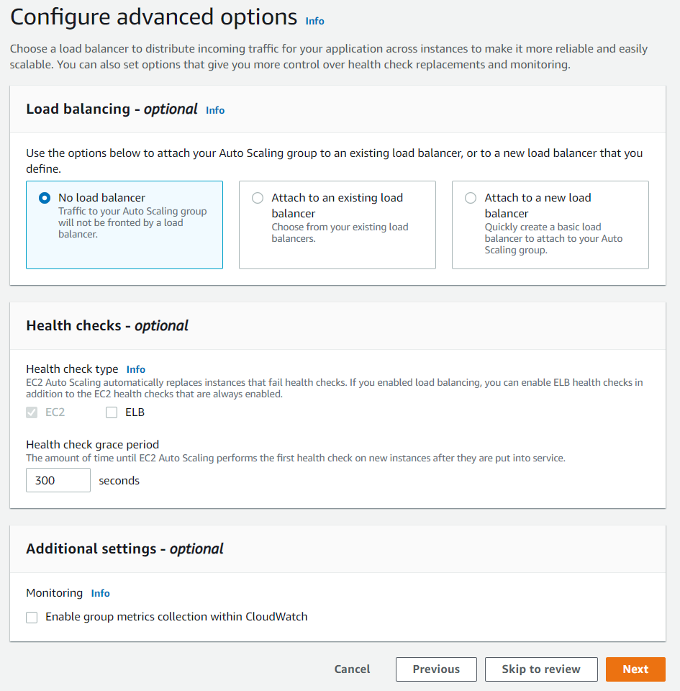

* 1. Click on Next
  2. In below Page enter
     1. 2 for Minimum Capacity, Maximum Capacity and for Desired Capacity

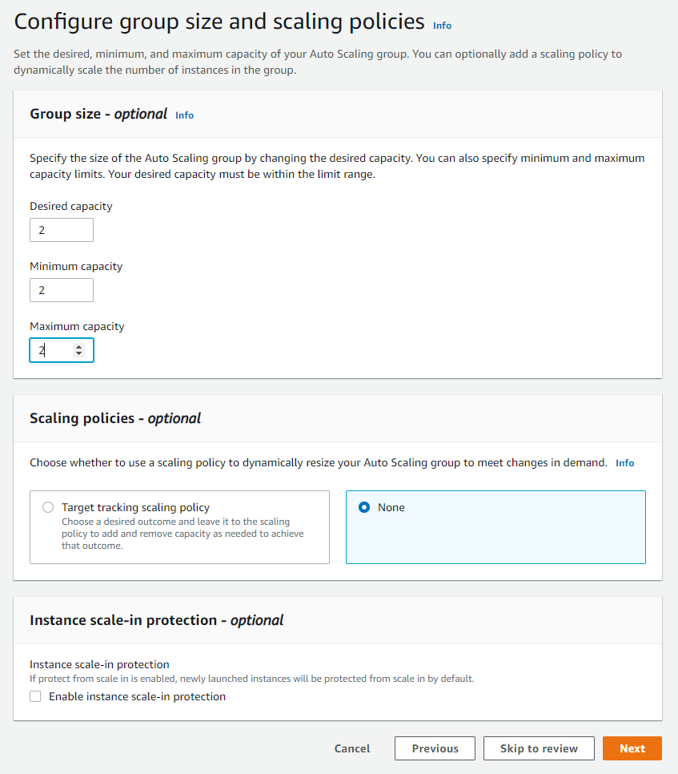

* 1. Click on Next
  2. Again Click on Next in Add Notifications Page
  3. Click on Next button in Add Tags page
  4. Click on Auto Scaling Group button in Review Page

1. The Auto Scaling Group gets created and Two EC2 Instances gets Started
2. For Testing
   1. Terminate One EC2 Instance and wait for 100 Secs then New EC2 Instance Should get started automatically
3. Onec your Lab is completed, **PLEASE DON’T FORGET TO DELETE AUTO SCALING GROUP and LAUNCH CONFIGURATION TEMPLATE, OTHERWISE THE EC2 INSTANCES KEEPS RUNNING EVNETHOUGH YOU TERMINATE THEM**

# **EFS LAB**

* Login to AWS Console
* Search for EFS and Click on it
* Click on Create File System
* You will see Configure File System Access screen
* Click on Next Step
* You will see Configure Optional Settings page
  + Enable Encryption of data
* Click on Next Step
* Review and Create 🡪 Hit Create File System
* While EFS gets created go to EC2 and provision two EC2 instances with below Bootstrap script (Amazon Linux 2 AMI)

#!/bin/bash

yum update -y

yum install httpd -y

service httpd start

chkconfig httpd on

yum install amazon-efs-utils -y

If you're using an Amazon Linux EC2 instance, install the EFS mount helper with the following command:

* Add NFS Protocol to Inbound Rule of Security Group
* Login to two EC2 instances from Git Bash separately
  + sudo su
  + cd /var/www/html –to verify if apache is installed
  + cd ..
* Go to EFS
* Click on Attach button at Top Right side
* Copy TLS Mount command similar to the one below
  + mount -t efs -o tls fs-4ff4e0ce:/ /
  + and modify this to below
  + mount -t efs -o tls fs-4ff4e0ce:/ /var/www/html
* Login to EC2 instances and execute above command
* Then Create index.html in one EC2 instance and you can see this on other EC2 instance
* Access the instances from Browser where you will be bale to see the changes in index.html